Date:14.06.2026
EX:1 write a python program to solve 8-puzzle problem

AIM
To write a Python program to solve the 8-Puzzle problem using the A* Search Algorithm.

ALGORITHM
- Define the initial state and goal state of the 8-puzzle.
- Use the A (A-Star) Search Algorithm* to find the solution.
- Calculate the heuristic value using the number of misplaced tiles.
- Find the position of the empty space (0) in the puzzle.
- Generate neighboring states by moving the empty space up, down, left, or right.
- Use a priority queue to select the state with the lowest total cost, f(n) = g(n) + h(n).
- Repeat the process while avoiding already visited states until the goal state is reached.
- Display the complete solution path from the initial state to the goal state.
PROGRAM CODE:
import heapq
goal = (1, 2, 3, 4, 5, 6, 7, 8, 0)
def heuristic(state):
return sum(
1 for i in range(9)
if state[i] != 0 and state[i] != goal[i]
)
def get_neighbors(state):
neighbors = []
zero = state.index(0)
row, col = divmod(zero, 3)
moves = [(-1, 0), (1, 0), (0, -1), (0, 1)]
for dr, dc in moves:
new_row = row + dr
new_col = col + dc
if 0 <= new_row < 3 and 0 <= new_col < 3:
new_pos = new_row * 3 + new_col
new_state = list(state)
new_state[zero], new_state[new_pos] = \
new_state[new_pos], new_state[zero]
neighbors.append(tuple(new_state))
return neighbors
def solve_puzzle(start):
queue = [(heuristic(start), 0, start, [])]
visited = set()
while queue:
f, cost, state, path = heapq.heappop(queue)

if state == goal:
return path + [state]
if state in visited:
continue
visited.add(state)
for neighbor in get_neighbors(state):
if neighbor not in visited:
new_cost = cost + 1
heapq.heappush(
queue,
(new_cost + heuristic(neighbor),
new_cost,
neighbor,
path + [state])
)
return None
start = (1, 2, 3,
4, 0, 6,
7, 5, 8)
solution = solve_puzzle(start)
if solution:
print("Solution found!")
for state in solution:
for i in range(0, 9, 3):
print(state[i:i+3])
print()
else:
print("No solution found.")

OUTPUT: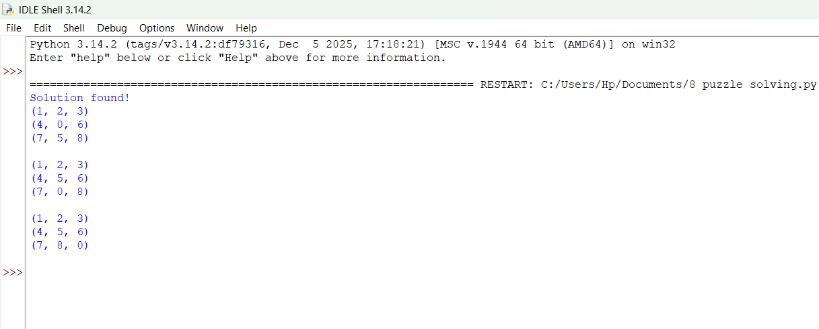

RESULT
Thus, the 8-Puzzle problem was successfully solved using the A Search Algorithm in Python*, and the goal state was reached.

